一、数据库结构

1、分类名表

tb_category{

id integer primary key autoincrement;

category_name text;

};

2、笔记本最后修改时间表

tb_book_time{

book_id integer primary key;

book_time timestamp;

};

3、笔记本属性表

tb_bookid{ //”bookid”在表创建时，取笔所获取到的bookid值

page_id integer primary key;

page_time timestamp;

category_name text;

page_name text;

pen_name text;

page_image text;

};

4、页面笔迹点属性表

tb_bookid_pageid{ /* ”bookid”和”pageid”在表创建时，取笔所获取到 的bookid和pageid值 */

id integer primary key autoincrement;

book_id integer;

page_id integer;

counter integer;

pointX float;

pointY float;

force integer;

type integer;

pen_width integer;

color integer;

angle integer;

};

二、实现步骤（OidActivity类）：

1、定义全局变量

代码：

private DatabaseHelper database_helper;  
 private SQLiteDatabase db;  
 private Map<Integer,Boolean> newDot = new HashMap<Integer,Boolean>(); //新点标志  
 private Map<Integer,Integer> save_sql_dot_num = new HashMap<Integer,Integer>(); //各页数据库点存储数  
  
 private String category_name = "默认";  
 private Handler save_sql_handler;  
 private Runnable save_sql_runnable;  
 private String[] allCategory_name;

1. 在onCreate()中接收Note_category_main类传送的信息

代码：

database_helper = new DatabaseHelper(this,"note_book.db",null,1);  
 Intent intent = getIntent();  
 designation = intent.getBooleanExtra("DESIGNATION",false);  
 allCategory_name = intent.getStringArrayExtra("ALLCATEGORY_NAME");  
 if (designation){  
 *dot_number*.clear();  
 int go_book_id = intent.getIntExtra("BOOKID",0);  
 int go_page_id = intent.getIntExtra("PAGEID",0);

SetBackgroundImage(go_book_id, go_page_id);  
 gImageView.setVisibility(View.*VISIBLE*); //视图可见  
 gCurBookID = go_book_id;  
 gCurPageID = go_page_id;  
 drawInit();  
 DrawExistingStroke(gCurBookID, gCurPageID);  
 }else {  
 category_name = intent.getStringExtra("CATEGORY_NAME");  
 }

1. 在SetBackgroundImage()中实现当前页数据初始化

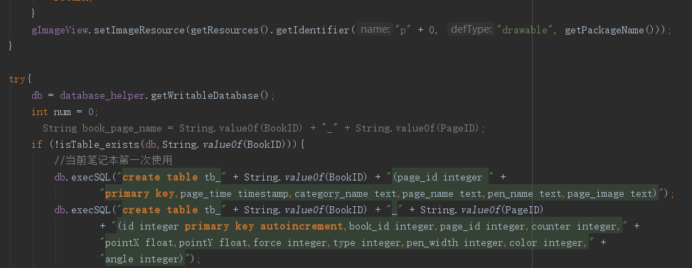

代码：

try{  
 db = database_helper.getWritableDatabase();  
 int num = 0;  
 if (!isTable_exists(db,String.*valueOf*(BookID))){  
 //当前笔记本第一次使用  
 db.execSQL("create table tb_" + String.*valueOf*(BookID) + "(page_id integer " +  
 "primary key,page_time timestamp,category_name text,page_name text,pen_name text,page_image text)");  
 db.execSQL("create table tb_" + String.*valueOf*(BookID) + "_" + String.*valueOf*(PageID)  
 + "(id integer primary key autoincrement,book_id integer,page_id integer,counter integer," +  
 "pointX float,pointY float,force integer,type integer,pen_width integer,color integer," +  
 "angle integer)");  
 ContentValues values = new ContentValues();  
 values.put("page_id",PageID);  
 values.put("category_name",category_name);  
 db.insert("tb_" + String.*valueOf*(BookID),null,values);  
  
 values.clear();  
 values.put("book_id",BookID);  
 db.insert("tb_book_time",null,values);  
 save_sql_dot_num.put(PageID,0);  
 Log.*d*(*TAG*, "SetBackgroundImage: PageID:" + PageID);  
 } else if (!isTable_exists(db,String.*valueOf*(BookID) + "_" + String.*valueOf*(PageID))){  
 //当前页第一次使用  
 db.execSQL("create table tb_" + String.*valueOf*(BookID) + "_" + String.*valueOf*(PageID)  
 + " (id integer primary key autoincrement,book_id integer,page_id integer,counter integer," +  
 "pointX float,pointY float,force integer,type integer,pen_width integer,color integer," +  
 "angle integer)");  
 ContentValues values = new ContentValues();  
 values.put("page_id",PageID);  
 values.put("category_name",category_name);  
 db.insert("tb_" + String.*valueOf*(BookID),null,values);  
 save_sql_dot_num.put(PageID,0);  
 } else {  
 try {  
 Cursor cursor = db.query("tb_" + String.*valueOf*(BookID) + "_" + String.*valueOf*(PageID),  
 new String[]{"book_id", "page_id", "counter", "pointX", "pointY", "force",  
 "type", "pen_width", "color", "angle"}, "book_id = ? and page_id = ?",  
 new String[]{String.*valueOf*(BookID), String.*valueOf*(PageID)}, null, null,  
 null);  
 if (cursor.moveToFirst()) {  
 //读取当前页笔迹点数据  
 do {  
 int book_id = cursor.getInt(0);  
 int page_id = cursor.getInt(1);  
 int counter = cursor.getInt(2);  
 float pointX = cursor.getFloat(3);  
 float pointY = cursor.getFloat(4);  
 int force = cursor.getInt(5);  
 int type = cursor.getInt(6);  
 int pen_width = cursor.getInt(7);  
 int color = cursor.getInt(8);  
 int angle = cursor.getInt(9);  
  
 Dots dots = new Dots(book_id, page_id, pointX, pointY, force, type, pen_width  
 , color, counter, angle);  
 *dot_number*.put(page_id, dots);  
 num++;  
  
 } while (cursor.moveToNext());  
  
 cursor.close();  
 } else {  
 //当前页数据被清空过  
 ContentValues values = new ContentValues();  
 values.put("page_id",PageID);  
 values.put("category_name",category_name);  
 db.insert("tb_" + String.*valueOf*(BookID),null,values);  
 }  
 } catch (Exception e){  
 e.printStackTrace();  
 }  
 save_sql_dot_num.put(PageID, num);  
 }  
  
 } catch (Exception e){  
 e.printStackTrace();  
 }  
 Log.*d*(*TAG*, "SetBackgroundImage: save_sql_dot_num:" + save_sql_dot_num);  
  
 newDot.put(PageID,false);

1. 在onCreate()中实现当前页笔迹点数据本地存储

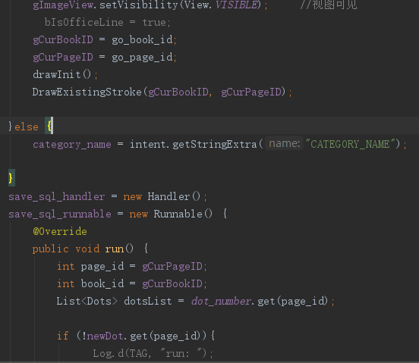

代码：

save_sql_handler = new Handler();  
 save_sql_runnable = new Runnable() {  
 @Override  
 public void run() {  
 int page_id = gCurPageID;  
 int book_id = gCurBookID;  
 List<Dots> dotsList = *dot_number*.get(page_id);  
  
 if (!newDot.get(page_id)){  
 return;  
 }  
 ContentValues values = new ContentValues();  
 String save_time = new SimpleDateFormat("yyyy-MM-dd hh:mm:ss:SSS").format(new Date());  
 values.put("page_time",save_time);  
 values.put("pen_name",ApplicationResources.*mPenName*);  
 db.update("tb_" + String.*valueOf*(book_id),values,"page_id = ?",  
 new String[]{ String.*valueOf*(page_id) });  
 values.clear();  
  
 values.put("book_time",save_time);  
 db.update("tb_book_time",values,"book_id = ?",new String[]{ String.*valueOf*(book_id) });  
 int num = save_sql_dot_num.get(page_id);  
 int dot_num = num;  
 int count = dotsList.size();  
 while (dot_num < count){  
 values.clear();  
 Dots dots = dotsList.get(dot_num);  
 values.put("book_id",dots.bookID);  
 values.put("page_id",dots.pageID);  
 values.put("counter",dots.ncounter);  
 values.put("pointX",dots.pointX);  
 values.put("pointY",dots.pointY);  
 values.put("force",dots.force);  
 values.put("type",dots.ntype);  
 values.put("pen_width",dots.penWidth);  
 values.put("color",dots.ncolor);  
 values.put("angle",dots.nangle);  
 long flag = db.insert("tb_" + String.*valueOf*(book_id) + "_" + String.*valueOf*(page_id),  
 null,values);  
 if (flag != -1){  
 num++;  
 }  
 dot_num++;  
  
 }  
 db.setTransactionSuccessful();  
 save_sql_dot_num.put(page_id,num);  
 newDot.put(page_id,false);  
 db.endTransaction();  
  
 }  
 };

1. 在ProcessEachDot()中对笔迹点数据存储进行起始和中断操作

### 5.1、在笔下落阶段

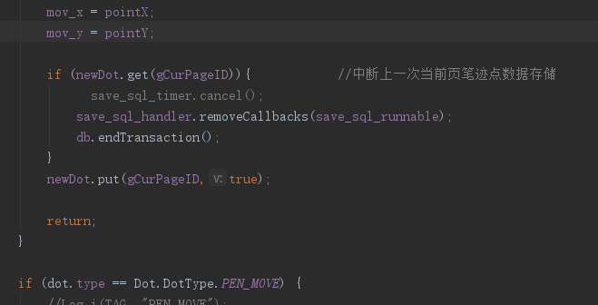

代码：

if (newDot.get(gCurPageID)){ //中断上一次当前页笔迹点数据存储  
// save_sql_timer.cancel();  
 save_sql_handler.removeCallbacks(save_sql_runnable);  
 db.endTransaction();  
 }  
 newDot.put(gCurPageID,true);

### 5.2、在笔拿起阶段

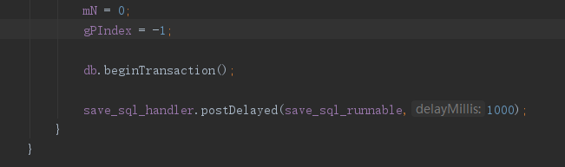

代码：

db.beginTransaction();  
  
save_sql_handler.postDelayed(save_sql_runnable,1000);

1. 实现当前页面指定保存

### 6.1、修改res/menu/option_menu.xml

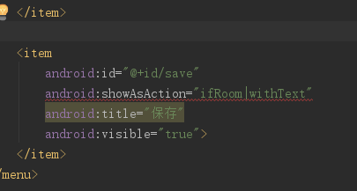

代码：

<item  
 android:id="@+id/save"  
 android:showAsAction="ifRoom|withText"  
 android:title="保存"  
 android:visible="true">  
</item>

### 6.2、更改onCreateOptionsMenu()

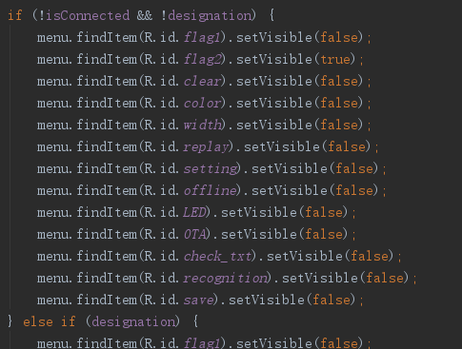

代码：

if (!isConnected && !designation) {  
 menu.findItem(R.id.*flag1*).setVisible(false);  
 menu.findItem(R.id.*flag2*).setVisible(true);  
 menu.findItem(R.id.*clear*).setVisible(false);  
 menu.findItem(R.id.*color*).setVisible(false);  
 menu.findItem(R.id.*width*).setVisible(false);  
 menu.findItem(R.id.*replay*).setVisible(false);  
 menu.findItem(R.id.*setting*).setVisible(false);  
 menu.findItem(R.id.*offline*).setVisible(false);  
 menu.findItem(R.id.*LED*).setVisible(false);  
 menu.findItem(R.id.*OTA*).setVisible(false);  
 menu.findItem(R.id.*check_txt*).setVisible(false);  
 menu.findItem(R.id.*recognition*).setVisible(false);  
 menu.findItem(R.id.*save*).setVisible(false);  
} else if (designation) {  
 menu.findItem(R.id.*flag1*).setVisible(false);  
 menu.findItem(R.id.*flag2*).setVisible(true);  
 menu.findItem(R.id.*clear*).setVisible(true);;  
 menu.findItem(R.id.*replay*).setVisible(true);  
 menu.findItem(R.id.*recognition*).setVisible(true);  
 menu.findItem(R.id.*save*).setVisible(true);  
 menu.findItem(R.id.*color*).setVisible(false);  
 menu.findItem(R.id.*width*).setVisible(false);  
 menu.findItem(R.id.*setting*).setVisible(false);  
 menu.findItem(R.id.*offline*).setVisible(false);  
 menu.findItem(R.id.*LED*).setVisible(false);  
 menu.findItem(R.id.*OTA*).setVisible(false);  
 menu.findItem(R.id.*check_txt*).setVisible(false);  
} else {  
 menu.findItem(R.id.*flag1*).setVisible(true);  
 menu.findItem(R.id.*flag2*).setVisible(false);  
 menu.findItem(R.id.*clear*).setVisible(true);  
 menu.findItem(R.id.*color*).setVisible(true);  
 menu.findItem(R.id.*width*).setVisible(true);  
 menu.findItem(R.id.*replay*).setVisible(true);  
 menu.findItem(R.id.*setting*).setVisible(true);  
 menu.findItem(R.id.*offline*).setVisible(true);  
 menu.findItem(R.id.*LED*).setVisible(false);  
 menu.findItem(R.id.*OTA*).setVisible(false);  
 menu.findItem(R.id.*check_txt*).setVisible(true);  
 menu.findItem(R.id.*recognition*).setVisible(true);  
 menu.findItem(R.id.*save*).setVisible(true);  
}

### 6.3、更改onOptionsItemSelected()

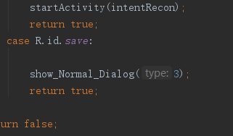

代码：

case R.id.*save*:  
  
 show_Normal_Dialog(3);  
 return true;

### 6.4、更改show_Normal_Dialog()

#### 6.4.1、初始

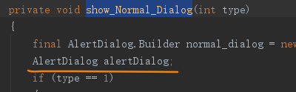

#### **6.4.2、定义当前页指定保持对话框**

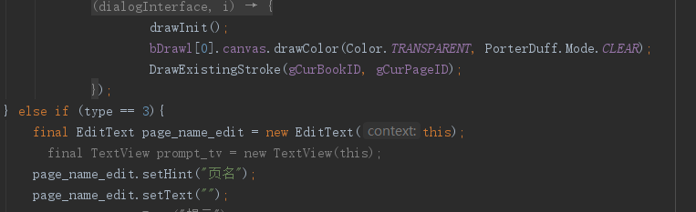

代码：

} else if (type == 3){  
 final EditText page_name_edit = new EditText(this);  
 page_name_edit.setHint("当前页页名");  
 page_name_edit.setText("");  
// prompt_tv.setText("提示");  
 final int[] pos = {-1};  
  
 normal_dialog.setTitle("请为当前页选择类别和输入页名");

normal_dialog.setSingleChoiceItems(allCategory_name, -1, new DialogInterface.OnClickListener() {  
 @Override  
 public void onClick(DialogInterface dialogInterface, int which) {  
 pos[0] = which;  
 }  
 });  
 normal_dialog.setView(page_name_edit);  
 normal_dialog.setPositiveButton("确定", new DialogInterface.OnClickListener() {  
 @Override  
 public void onClick(DialogInterface dialogInterface, int i) {  
 String page_name = page_name_edit.getText().toString();  
 if (pos[0] == -1 || page_name.isEmpty()){  
 Toast.*makeText*(OidActivity.this,"请选择类别或填充页名",Toast.*LENGTH_SHORT*).show();  
 } else {  
 String chosen_category_name = allCategory_name[pos[0]];  
 ContentValues values = new ContentValues();  
 values.put("category_name",chosen_category_name);  
 values.put("page_name",page_name);  
 db.update("tb_" + String.*valueOf*(gCurBookID),values,"page_id = ?",new String[] { String.*valueOf*(gCurPageID) });  
 }  
 }  
 });  
 normal_dialog.setNegativeButton("取消", new DialogInterface.OnClickListener() {  
 @Override  
 public void onClick(DialogInterface dialogInterface, int i) {  
  
 }  
 });  
   
 }

#### **6.4.3、修改show()方法**

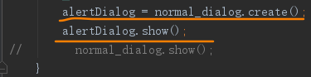

二、参考资料：

定时任务执行：https://www.cnblogs.com/fozero/p/5876328.html

三、改进建议：

在OidActivity()整体布局界面风格统一以后，可将对话框重新自定义，并添加默认保存类别修改功能。